Ideation Phase

Brainstorm & Idea Generation & Prioritization

Date | 9 September 2026
Project Name | Employee Raise Issue
Maximum Marks | 4 Marks

Brainstorm & Idea Generation
The brainstorming phase for the Employee Raise Issue project focuses on creating a simple, standardized and user-friendly way for employees to raise workplace issues through ServiceNow. The ideas emphasize structured information capture, guided issue submission, controlled field choices, form usability, validation, automation and reporting. The objective is to reduce incomplete requests, improve issue tracking and provide a clear process for employees and administrators

No. | Problem Area | Generated Idea
1 | Unstructured issue reporting | Create a custom Employee Raise Issue table to store issue information in a consistent formation
2 | Incomplete information | Use mandatory fields and UI Policies to ensure required details are captured.
3 | Difficulty selecting issue details | Use controlled and dependent choices so employees can select relevant options.
4 | Complex submission process | Create a Record Producer with a simple guided form for raising issues.
5 | Poor user accessibility | Provide access through a Service Portal for an easier employee experience.
6 | Lack of validation | Apply client-side validation and UI Policies to improve data quality.
7 | Limited status visibility | Track submitted issues using records, lists and appropriate status fields.
8 | Manual follow-up | Consider notifications and automation for future workflow improvements.
9 | Difficult monitoring | Create reports and dashboards to monitor issue volume and progress.

Idea Generation
During brainstorming, the following possible ServiceNow components and enhancements were considered for the Employee Raise Issue project:

Idea | Purpose
Scoped ServiceNow Application | Provide a dedicated application for managing employee-raised issues.
Custom Employee Raise Issue Table | Store issue details, employee information, category, description and tracking
Record Producer | Allow employees to submit an issue through a simple and guided form.
Dependent Choices | Show relevant choices based on the selected issue category or type.
UI Policies | Control field visibility, mandatory status and read-only behavior
Client-Side Validation | Improve data quality by validating entered information before submission
Service Portal | Provide a convenient and employee-friendly interface for raising issues.
Notifications / Automation | Support future automated alerts and assignment or status updates.
Reports & Dashboards | Help administrators monitor issue counts, categories, status and trends.

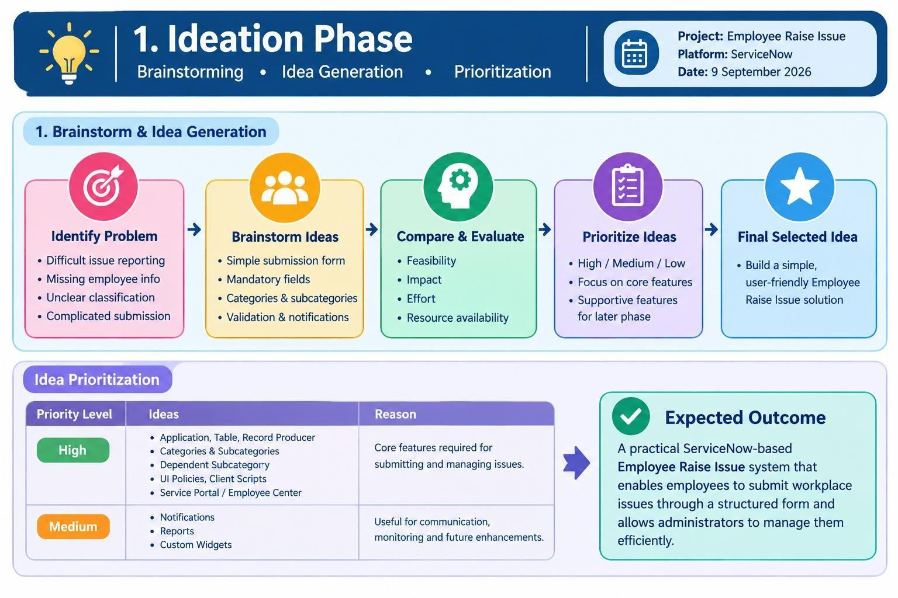

Idea Prioritization

The generated ideas were prioritized according to their importance to the core Employee Raise Issue functionality. High-priority ideas directly support issue creation, structured data capture and form usability. Medium-priority ideas support future enhancement, automation and monitoring

Idea Group | Priority | Reason for Priority
Scoped ServiceNow Application | High | Forms the foundation for organizing the project in a dedicated application
Custom Employee Raise Issue Table | High | Provides structured storage and tracking of employee issues.
Record Producer | High | Provides a simple and guided way for employees to raise an issue.
Dependent Choices | High | Helps users select relevant values and improves data consistency.
UI Policies | High | Controls fields dynamically and supports a user-friendly form.
Client-Side Validation | High | Reduces incorrect or incomplete information before submission.
Service Portal | High | Improves accessibility and employee experience.
Notifications / Automation | Medium | Useful for future alerts and reducing manual follow-up.
Reports / Dashboards | Medium | Useful for administrative monitoring and analysis.
Custom Widgets | Medium | Can enhance the portal experience but is not essential to core submission

Final Selected Ideas
Based on the prioritization, the core solution is centered on a custom ServiceNow application, a dedicated Employee Raise Issue table, a Record Producer, controlled choices, UI Policies, validation and Service Portal access. Automation and reporting are treated as supporting enhancements that can be extended as the project evolves.

Expected Outcome
The brainstorming and prioritization process results in a practical ServiceNow-based solution where employees can raise issues in a standardized manner, administrators can manage the submitted records efficiently, and the organization can later extend the solution with notifications, automation, reports and dashboards.

